FHIMS WG Terminology Modeling Sub-Project Meeting

Summary of Call

Date/time of call: Wednesday, May 15, 2013, 2:00 - 3:30 PM

|  |  |  |  |
| --- | --- | --- | --- |
| **Attendees** | | | |
| Jay Lyle - FHA PMO | Y | Robert Crawford – VA |  |
| Rob McClure - VA/VHA | Y | Nancy Cornish – CDC |  |
| Bill Hess – FDA |  | LuAnne Barron – VA |  |
| Galen Mulrooney - VA/VHA |  | Riki Merrick | Y |
| Susan Matney – 3M |  | Kevin Coonan |  |
| Jim Case – NLM |  | Mary Beth Gagnon - CDC |  |
| Steve Wagner – FHA | Y | Pam Banning |  |
| David Bass – VA |  | Glen Janzen – IHS |  |
| Mark Roche | Y | Steve Hufnagel – DoD |  |
| Sean Muir – VA |  | Rob Savage – CDC |  |

Agenda

1. Immunization review for Friday, with Rob Savage
2. Lab
   1. Where lab codes go for order, result
      1. Add instance object diagram to illustrate common patterns?
   2. Organism pattern
      1. **560-3 "Chlamydia sp identified Prid Pt XXX Nom Organism specific culture**
         1. result = positive, negative (or detected, not detected)
      2. **23667-9  "Bacteria identified Prid Pt XXX Nom"**
         1. organism = Chlamydia, result = positive, negative (or detected, not detected)
      3. Result in MicroscopyFinding.evaluationFinding or in InterpretationEvent.interpretation?
3. Demographics review
   1. Requests going to PHIN VADS
   2. Remove “normal” from V3 state machine value sets
      1. This makes the value sets FHIM value sets rather than HL7 value sets.
      2. Review definitions
   3. Two administrative genders
4. Value set composition & design: Can we use a grouping value set to exclude, e.g., flavors of null?
   1. Grouping: Routes of administration
      1. FDA routes
      2. CDC Subset of FDA values + “other”
      3. Null flavors
   2. Adopt HL7 approach of ‘required, allowed, prohibited’ sets?
5. PHIN VADS and VSAC
   1. If we use both, we have to publish to both
   2. Synchronization & precedence
   3. Metadata
   4. Possibility of syndication—publishing to one of (VSAC, PHIN VADS, UMLS, caBig, USHIK) and convincing the others to reference the one
   5. VSAC charter, goals, policies (MU vs. Everything)
6. Preview of allergy domains
   1. FHIM reactant is a property of the condition; DAM has it as a separate class
      1. DAM allows capture of exposures to multiple substances prior to determining which one caused an episode.
      2. The sensitivity test might be a subclass of this.
   2. Both models capture a general condition type (“allergy,” “sensitivity”) with a specific reactant, rather than a more specific condition with no reactant (e.g., “allergy to peanuts”).
      1. EMS uses the specific allergy condition for simplicity.
      2. And also because the SCT condition codes work well for environmental allergens, whereas UNII materials do not provide higher level concepts. (E.g., it has duck feathers, goose feathers, and chicken feathers, but not feathers; ditto for makeup, bee stings, and others.)
   3. FHIM models a reaction as an event in time. DAM models a reaction as a symptom, which may have several temporal manifestations
      1. Recommend FHIM model  make the reaction property a repeating element in the reaction class (and possibly rename the class to “episode”); an episode may have more than one symptom.
      2. Recommend the DAM relate the condition to the episode (“manifestation”) rather than the reaction. Thinking forward, it’s true that the condition does create the expectation of the reaction, but we only know that from episodes, which actually happened, and have no “expectation” associated with them.
   4. VMR model makes a propensity to adverse reaction an event with no adverseEventTime. The team at the Atlanta WGM realized this was problematic and will revise the model.

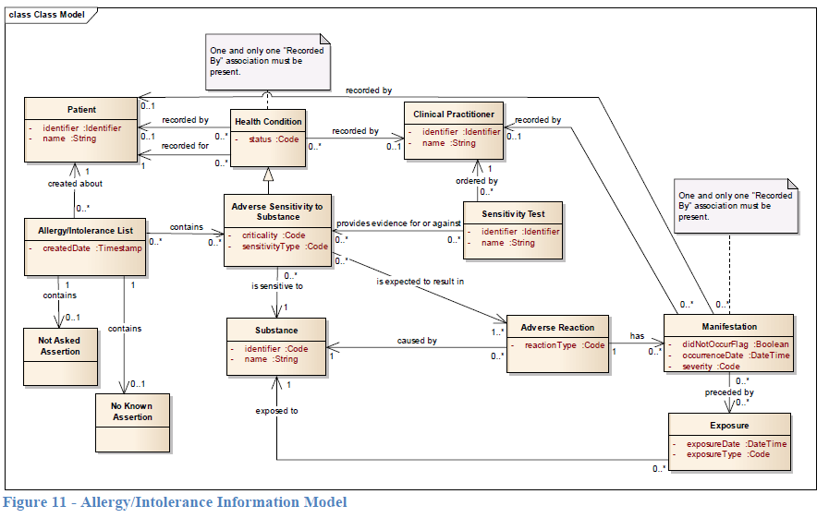

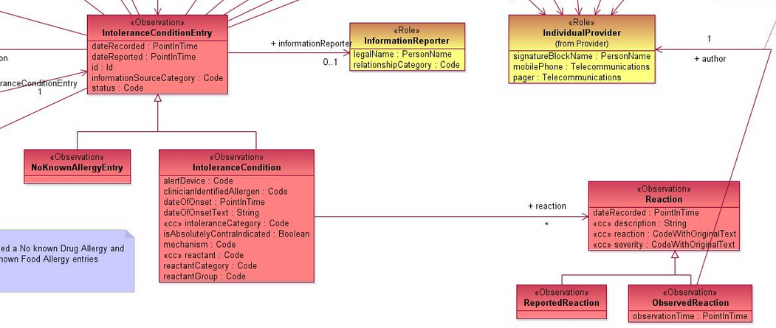

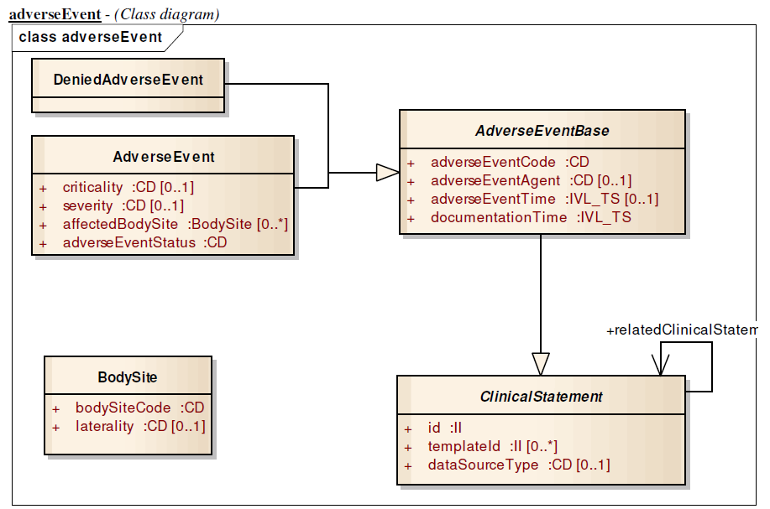

**Schedule of Future Meetings**

1) The weekly general Information Modeling (IM) project call is held each Friday from 2:30 to 4:30 PM Eastern Time.

Information for participating in the calls:

Name: FHIMS WG Information Modeling Project Call

Recurring Weekly Call Every Friday

Time of Call: 2:30 to 4:30 PM Eastern Time

Dial-in Information: 1 (773) 897-3018, Access Code: 585-151-437

Web Meeting URL: https://global.gotomeeti​ng.com/meeting/join/5851​51437

2) The weekly Terminology Information modeling calls are held on Wednesdays from 2-3:30 PM Eastern Time.

Information for participating in the calls:

Name: FHIMS WG Information Modeling Project Call

Recurring Weekly Call Every Wednesday

Time of Call: 2:00 to 3:30 PM Eastern Time

Dial-in Information: 1 (773) 897-3018, Access Code: 585-151-437

Web Meeting URL: https://global.gotomeeti​ng.com/meeting/join/5851​51437

**Action Items**

| Item Description | Responsible Individual | Due Date |
| --- | --- | --- |
| Acquire sample messages   * In process: values, not messages, which have not been scrubbed * Regenstrief initially responsive, but no response for months * Also will engage VA | Jay | 4/11 |